Writing Assignment 3

Student's Name
Institutional Affiliation
Course
Instructor's Name
Date

Writing Assignment 3
Question 1
Markets and Circular Flow of Income
An economy has four key markets: resource market, goods and services market, loanable funds market, and the foreign exchange market. The circular flow of income indicates the flow of income earned by the households through the four markets. The resource market is the market where the household and firms exchange production factors. The firms obtain factors of production such as labor, capital, and land from the resource market. Households supply these factors of production to the resource market. Prices in the resource market are determined by the demand and supply forces. Income earned by the households from the resource market denotes the national income. A portion of the income from the resource market is "leaked" out of the circular flow through government taxes.
The goods and services market is where the firms supply finished goods for sales revenues. This market accounts for the entire GDP. The firms here gain revenues from four different expenditures. The demand for goods and services in this market is attained from household expenditure on consumption, government purchases, and export and business investments. The loanable market is the money market whereby people borrow and lend money. It bridges the gap between those who wish to borrow money and those who want to lend it. Domestic savings are the primary sources of loanable funds. The desire for businesses to invest more and the government to finance budget deficits causes borrowing. Interest rates are the prices in the loanable funds market, bringing balance between the supply and demand for loanable funds.
The foreign exchange market allows for the exchange of currencies between nations. The conversation happens in the process of international trading, as economies export and import goods and services. If a country imports goods, it will convert the domestic currency to match the currency of the importing nation to make the transaction. The opposite is true if the country exports commodities. A significant flow of household income earned from selling resources is spent on goods consumption. This forms revenues for businesses which are in turn spent to purchase resources. "Leakages" occur through savings, taxes, and imports. In return, injection to the circular flow is done through government expenditure, exports, and borrowing from the loanable fund market.
Question 2
Self-Adjustment in the absence of Government Intervention
In the absence of government intervention, the economy self-adjusts itself from shock to retain the initial full employment. When the aggregate demand increases in a fully employed economy, the employment of resources rises beyond the standard capacity. Over time, however, the prices will increase, both for products and resources. Consequently, production cost becomes costly, and aggregate supply declines. Therefore, the output drops to adjust the price to a new equilibrium, with higher prices and a slight increase in production. A fall in aggregate demand will lead to lower prices, lower output, and lower profit margins and employment. Due to lower wage rate and prices, production cost becomes cheap, and firms invest more in the long run. Therefore, employment increases, increasing disposable income and aggregate demand too.
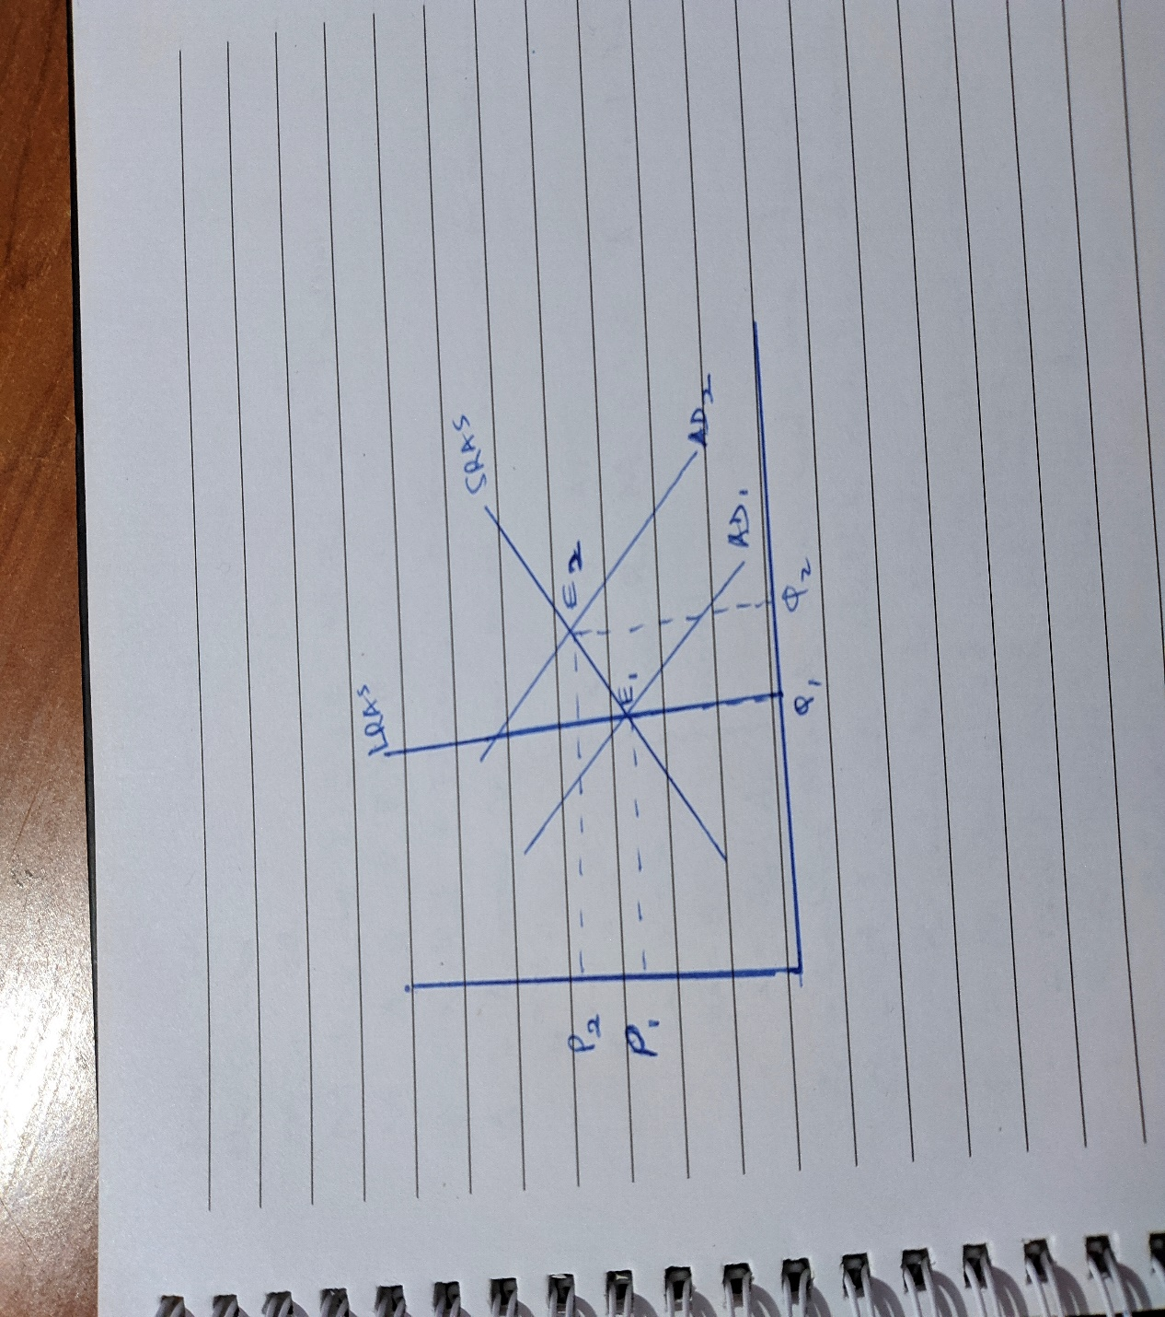
An unanticipated increase in aggregate demand will shift the quantity demanded from Q1 to Q2and the aggregate demand from AD1 to AD2. However, the increased prices will render production costs expensive. Hence the supply will reduce, and fewer resources will be demanded. Consequently, low employment will reduce the aggregate demand to the initial level. The new equilibrium will be vertically above E1, with reduced demand and initial employment but higher prices.
Impact of Changes in Prices and Interest Rates during Recession
During a recession, the aggregate demand is low. There is the unemployment of the resources. Besides, The down market causes a decrease in prices. The decreased prices reduce the production costs hence increasing the profit margin for firms. This acts as an incentive for businesses to revive from the recession. Industry revival increases employment, consequently increasing the demand as the economy gets back to full employment.
During the recession, the businesses reduce borrowing rates due to low returns on investment. People use more money for consumption and savings. Therefore, the loan interest rates decline, indicating that loans become cheap. This motivates businesses to borrow and invest cheaply from the loans. The investment from loans stimulates employment and more demand. Therefore, the rejuvenation of companies booms the economy back to full employment.
Question 3
A fractional reserve banking source
When you deposit $2000 in a bank at a reserve ratio of 10%, $200 is kept in the Federal Reserve Bank as a reserve. The commercial bank remains with extra $1800 reserve cash, which can be extended as a loan. If the bank extends the loan to a borrower, it adds money to circulation. Also, the bank lenders the loan at a higher interest rate, say, 15%, to get profits. Therefore, through the $2000 deposit, the economy gets $1800 more injection, and the bank earns $270 while my money is still intact. Thus, the deposit is capable of creating an extra $2,270 in the economy.
By depositing money in banks, the bank gets a chance to create money out of the deposit. The creation of money is mainly through lending to all qualified customers. The customers can pay the money bank with nice interests. The bank acts as an intermediary between lenders and borrowers. After deposition, the bank lends out people's money to make extra money. In fixed saving, the banks' interest rates are always less than what they loan to borrowers. In that way, the bank manages to create money to pay the employees, make profits, and generate more money for future lending.

